“Intelligent Vehicle Technologies & Smart Mobility”

Syllabus SCT.01/3

Prof K. Kyamakya, Prof J.C. Chedjou, AAU/Austria

March, 21th, 2019

Version 1

1. Title of the Course

Intelligent Vehicle Technologies & Smart Mobility
(Prof K. Kyamakya, Prof J.C. Chedjou, AAU/Austria)

2. ECTS Credits

5 credits (Lecture - 45 hours, Practice - 30 hours)

3. Course Objectives

The course consists of 2 Modules:

- MODULE A: Intelligent Vehicle Technologies
- MODULE B: Smart Mobility

4. The Contents of the Course

MODULE 1: INTELLIGENT VEHICLE TECHNOLOGIES

(1.1) General Introduction
- ITS (intelligent transport systems) overview
- Intelligent vehicles initiatives in various countries (USA, EUROPE, JAPAN)
- Core ITS services, a brief overview
- General architecture(s) / frameworks for intelligent vehicles
- Five key stages to the processing aspects of a self-driving vehicle
(1.2) Enabling Technologies
- Environment perception for intelligent vehicles
  - Road detection and tracking (lane detection, lane tracking, road recognition)
  - Vehicle detection and tracking
  - Multiple-sensor based multiple-object tracking
  - Dynamic environment modeling
- Vehicular communication
- Positioning technologies/concepts and digital maps
  - GPS based localization fundamentals
  - Integrated DGPS/IMU (differential global positioning system / inertial measurement unit) positioning approach
  - Vehicle navigation using global views
  - Framework(s) for vehicle localization and map building
- Big data in road transport and mobility research
- Prediction and routing
- Path planning and decision making
- Control of intelligent vehicles
  - Lateral motion control
  - Longitudinal motion control
(1.3) Applications
- Driver assistance systems and safety systems
- Cooperative systems
- Automated driving
- Use cases for autonomous driving
(1.4) Further Aspects (incl. social, economic, simulation, and research)
- Human factors (human driver behaviors, user interface(s), impact of automated cars/vehicles on society and mobilities)
- Law, ethics and liability issues (special legal questions, product liability, regulation, risks assessment (technical, legal, and economic))
- Acceptance issues
- Simulation tools (driving simulators, traffic simulation, data for training models, domain adaptation)
- The socio-economic impact of the intelligent vehicles: implementation strategies
- Future perspectives and hot research areas/issues

(1.5) Simulation exercises of intelligent vehicles using open source software tools

Software Tools (open source):
- Apollo
- Autoware

MODULE 2: SMART MOBILITY

(2.1) General Introduction
- Urban mobility trends and challenges (traffic congestion, parking problems, traffic accidents, energy consumption, environmental impacts)

(2.2) Fundamentals
- Urban mobility systems & infrastructures
  - Urban transport systems (UTS) definitions
  - Examples of the need for UTS engineers
  - Example of a simulation tool to simulate UTS: MATSim
- Monitoring mobility in smart cities (introduction to big data, monitoring mobility, time geography, travel momentum fields (TMF), TMF – transport route projections, TMF – before-after analysis)
- Modeling and simulation of mobility systems – a brief introduction
- Learning from public information / inverse transportation problems (machine learning applications in urban transport, inverse transportation problems, multiagent inverse transportation problems, network learning)
(2.3) Systems
- The 5 smart digital layers (urban layer (smart buildings, smart grid, smart mobility, smart waste management); sensor layer (this layer includes smart devices that measure and monitor different parameters of the city and its environment); connectivity layer (this layer involves the transport of data and information from the sensor level to storage and to data aggregators for further analysis); data analytics layer (this layer involves the analysis of data collected by different smart infrastructure systems, to help predict some events (such as traffic congestion); automation layer (the digital enabling interface layer that enables automation and scalability for a large number of devices across multiple domains and verticals)).
- Technologies and data transmission in ITS and smart mobility
- Smart cities, smart communities: definitions of the concepts
- Smart mobility in urban/metropolitan areas + case studies
  - People mobility (walking and cycling, sharing mobility systems (bike sharing, car sharing, ride-sharing and ride hailing), local public transport, integrated multi-modal transport and smarter mobility services)
  - Transport demand management (real-time traffic management, smart parking)
  - Urban freight and city logistics
  - Green mobility and low emission zones (clean and energy efficient vehicles, congestion charges and low emission zones)
  - Other mobility solutions of the future
- Building blocks of intelligent mobility
  - Smart mobility program management
  - Smart services (mobility platforms for route optimization and intermodal ticketing in transportation, smart parking solutions, automated logistics, new flexibility in public transport)
  - Smart data
  - Smart products
  - Smart spaces
- Automation and autonomous driving in mobility systems
- Mobility as a Service (MAAS) – a brief overview
- Human factors
(2.4) Mini-Project
- A mini-project or a study-seminar in groups (2-3 students per group)
- An open source simulation software should be used.
- Simulations of interesting scenarios of urban mobility. Tool: Polaris
(2.5) Field visit
- Visit one infrastructure/facility, a project, a manufacturer or a relevant service provider in the region

6. Training method

Theoretical part of the course:
- Slides (to be placed in Moodle)
- Selected videos fitting the respective chapters (sources: Youtube, online open courses, etc.)
- Small weekly assignments. Deliverables-1: solutions to be uploaded in Moodle

Practical part of the course:
- Various simple simulations experiments using the named software tools
  - Deliverables-2: Demos to be presented in front of all the class
- 3 students mini-seminars in groups of 2 students; 1 topic for each module
  - Deliverables-3 for each mini-seminar: 20 minutes presentations for each group
- A complex research project / study on a selected theme (teacher suggests some topics) of relevance to the course
  - The research project may involve also complex simulations
  - Deliverables-4: (1) a 20-30 minutes presentation; (2) A 6 pages paper/report summarizing the project/research outcome. Format: IEEE paper style. Paper editor: Latex.
- If possible, one industrial visit in a company working in one of the three relevant fields

7. Evaluation method

Students are evaluated by progressive control/assessment through the 4 Deliverables listed above and a final written exam control.

The final grade has 2 major components:
- Deliverables-1: the weekly assignments accompanying the theoretical course: 10%
- 3 Deliverables: -2, -3, and -4: 50%
- Final written exam: 40%

8. Software

POLARIS transportation system simulation software (open source):

https://www.anl.gov/es/polaris-transportation-system-simulation-tool

One or two of the following open source simulation tools:

- Apollo
- Autoware
- EB robinos & EB Robinos Predictor – Elektrobit
- NVIDIA DriveWorks
- OpenPilot

9. Bibliography / Recommended textbooks

BOOKS ON INTELLIGENT VEHICLES

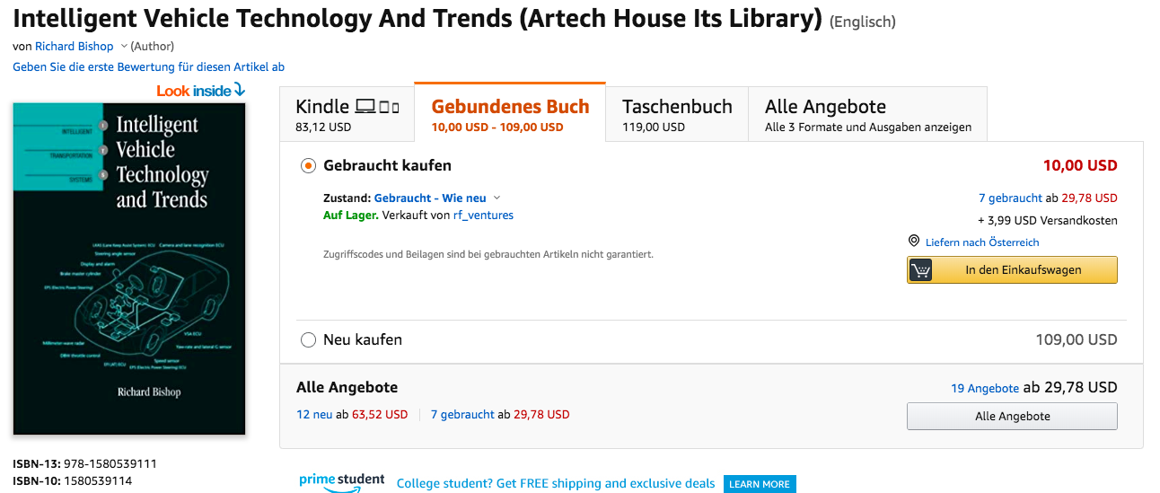

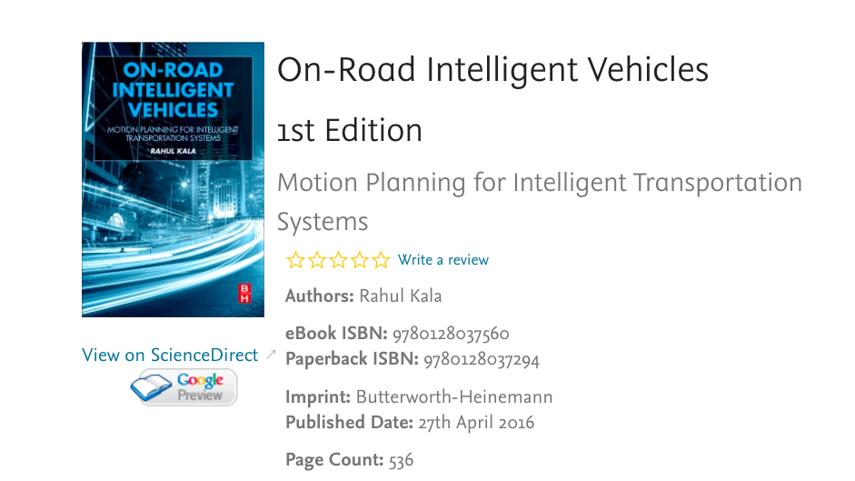

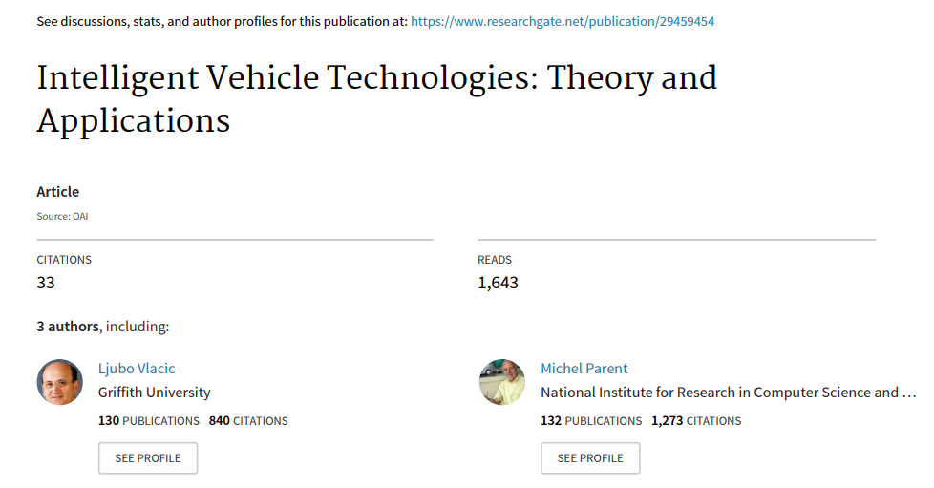

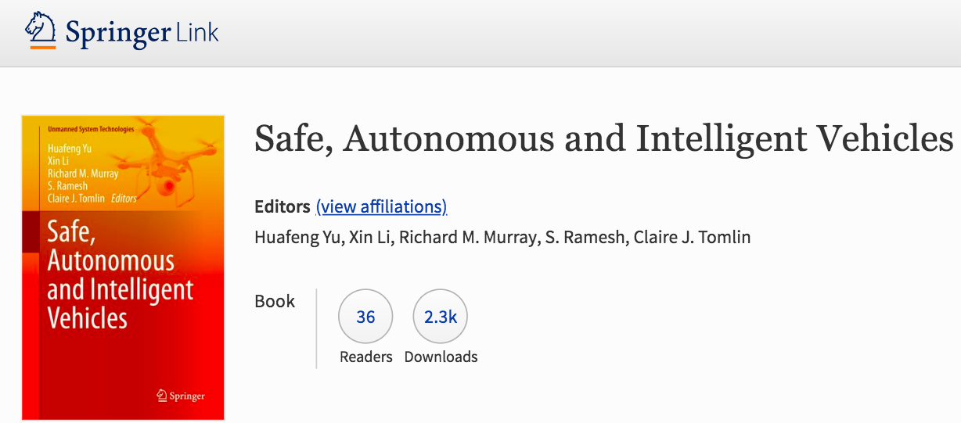

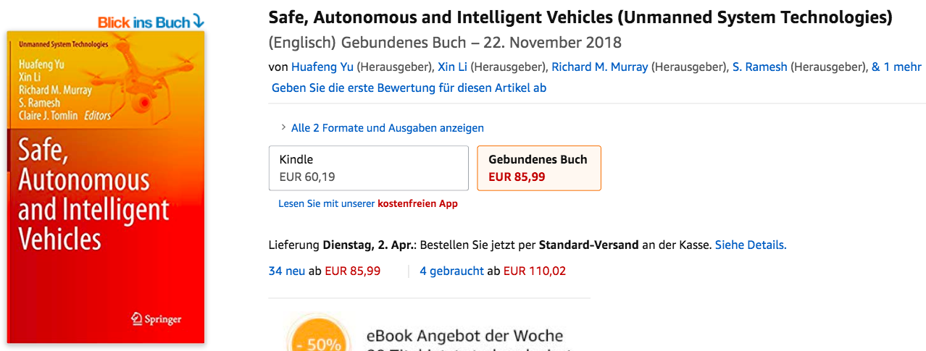

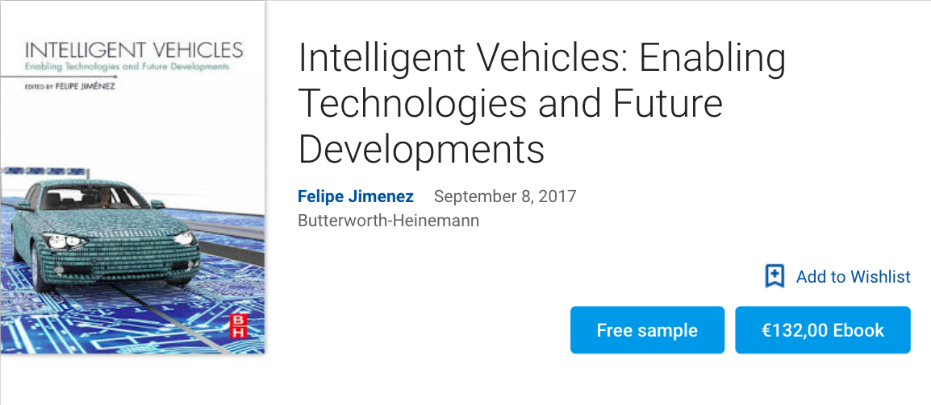

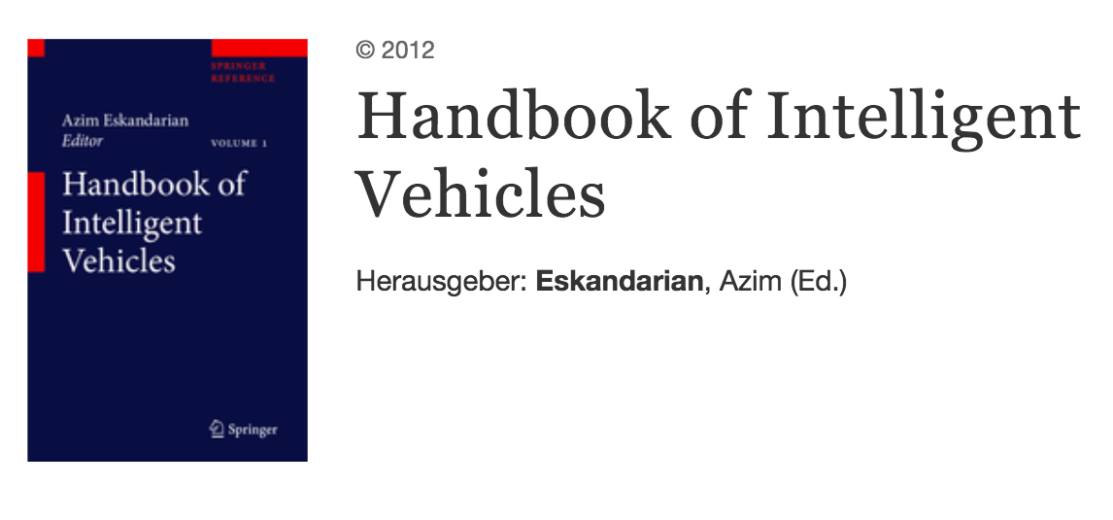

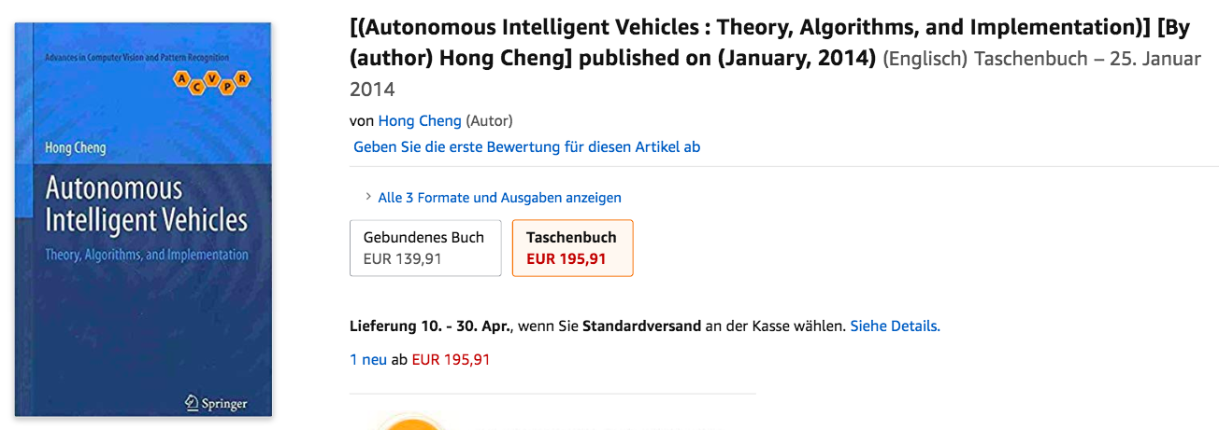

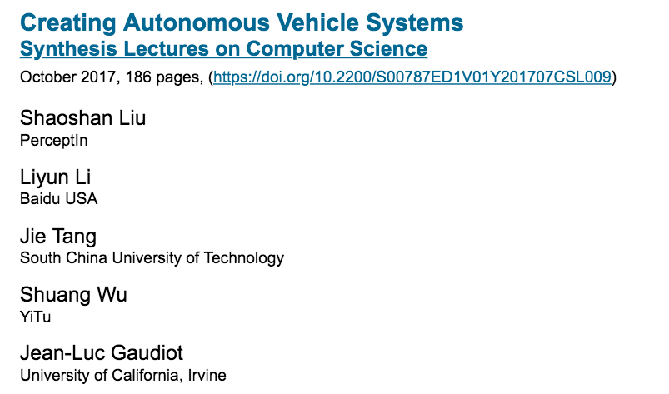

BOOKS ON SMART MOBILITY

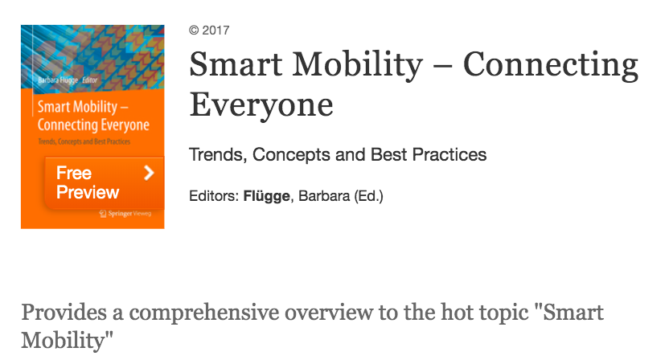

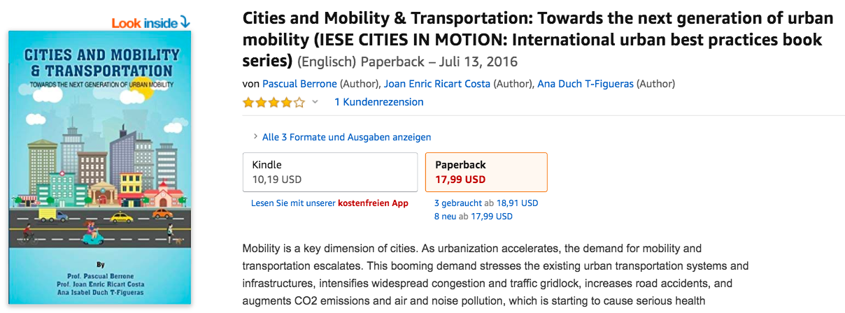

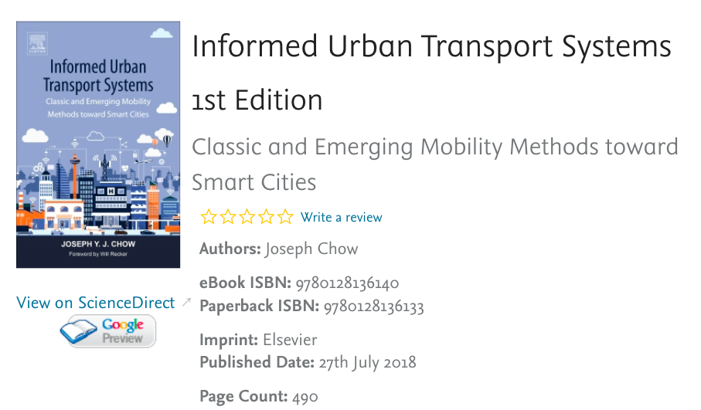

Source, see Chapter 2 of the Book: https://www.amazon.com/dp/B01IFBO5ZQ/ref=rdr_kindle_ext_tmb
Source, see Chapter 1 and 2 of the Book: https://www.amazon.com/dp/0128136138/ref=rdr_ext_tmb
Source (s. page 7): https://unctad.org/meetings/en/SessionalDocuments/ecn162016d2_en.pdf
Source, see Chapter 3 of the Book: https://www.amazon.com/dp/B01IFBO5ZQ/ref=rdr_kindle_ext_tmb
Source, see Parts II and III of the book: https://www.amazon.com/Smart-Mobility-Connecting-Everyone-Practices/dp/365815621X/ref=sr_1_3?keywords=Smart+mobility&qid=1552572735&s=gateway&sr=8-3

